HCI Design Brief

Project: *Golf Putting Simulator Design.*

*International manufacturer of golf equipment*

Author: Name

S Number: Number

*Workshop:* Day, Time, Instructor

Contents

1 Introduction 1

1.1 Purpose of this document 1

1.2 Scope of this document 1

1.3 The Customer 1

1.4 Background 1

1.5 Problem statement 2

1.6 Proposed solution 2

2 Audience 3

2.1 User Research - Desired 3

2.2 User Research – Actual 3

2.3 Human Factors 4

3 Usability 5

3.1 Usability Tools 5

3.2 Usability Findings 6

3.3 Usability Objectives 7

4 Design 8

5 Prototype 9

5.1 *Hierarchy chart* 9

5.2 Stage One – Low-Fidelity Prototype 9

6 Conclusion to part one 12

7 References 12

8 Appendix Part1 12

8.1 Appendix 1.1 - Contextual Interviews 12

8.2 Appendix 1.2- Brainstorming 16

8.3 Appendix 1.3 - White board 16

9 Discussion – User Involvement 17

9.1 Current approach discussion 17

9.2 Approach with User Centred Design (UCD) 17

10 Testing 17

10.1 Test Plan 17

10.2 Test Results and Analysis 21

10.3 Findings and Recommendations 21

11 Discussion – Accessibility 22

12 Prototype 22

12.1 Stage Two – High-Fidelity Prototype 22

13 Discussion – Contexts of Use 29

14 Discussion – Emerging Technology 29

15 Conclusion 30

16 References 30

17 Appendix Part 2 30

17.1 Appendix 1.2 – Consent form example 30

17.2 User Testing Photos 32

Figure 1 Hierarchy chart 9

Figure 2 landing page 10

Figure 3 Simulation 10

Figure 4 Learn page. 11

Figure 5 Setting 11

Figure 6 high fidelity prototype 21

Figure 7 Landing page 22

Figure 8 Putting Simulator 23

Figure 9 Learn Golf Page. 24

Figure 10 User Page 25

Figure 11 Settings Page 26

# Introduction

## Purpose of this document

The purpose of this document is to explore the human Interactions associated with designing technology and how that technology is designed with human interactions at the forefront of the design scope.

This document outlines the design process for creating an interactive golf putting simulator for a major international manufacturer of golf equipment. The goal is to address the client's request to develop a solution that assesses a user's ability to read the green, select the correct line, and strike the ball with suitable power for successful putting.

## Scope of this document

The scope of this document is to primarily focus on research and design aspects, along with the potential addition of a limited prototype. Due to accessibility limitations, some design assumptions will be made on behalf of the client. The first design will encompass a stable functional model representing the proposed low-fidelity prototype, including expected usability, user requirements, mock-ups, and wireframes to convey the product's visual and functional aspects.

As the high-level prototype progresses, the document will include storyboards highlighting the complete layout and colour scheme. If time and scope permit, a limited web design prototype will be created to simulate the final application for user testing purposes.

## The Customer

The customer for this project is a major international manufacturer of golf equipment. With a strong stand in the golf industry, they are committed to enhancing the overall golfing experience for players of all skill levels as they prioritize innovation and the development of cutting-edge technologies to address challenges in the sport.

The client has identified a critical need in the world of golf, specifically in improving putting skills. Putting constitutes a significant portion of a golfer's game so the client's primary objective is to create an interactive golf putting simulator that assesses a player's ability to read the green, select the correct line, and execute the putt with the right power. They aim to leverage technology to enhance the putting proficiency of golfers.

## Background

The sport of golf makes putting as a crucial aspect of a golfer's performance, contributing to nearly half of their score. While golf instruction has traditionally focused on putting kinematics, misreading the green has been recognized as a major reason for missed shots on the golf course.

The aim of this project is to solve this challenge by developing an interactive simulation tool. This tool is designed to help users in improving their ability to accurately read the green, hence enhancing their skills in reading and understanding the physics of the putting surface.

## Problem statement

The project's aim is to develop an interactive golf putting simulator that effectively calculates a user's capability to read the green accurately, choose the correct putting line, and strike the ball with the appropriate power. The primary challenge is to replicate real green reading scenarios and assess whether the simulator can enhance a player's ability to reduce radial putting errors and improve their overall putting performance.

## Proposed solution

The proposed solution involves developing a mobile application which is designed to enhance players experience as it will use the camera of the mobile and some complex image processing algorithms that will help the player know how the ball reacts when at a certain speed it is hit and how far it has travelled.

**Technologies Utilized:**

* **Mobile Camera:** The mobile camera will be used to capture the user's environment, mainly on the ball.
* **Image Processing:** Image processing algorithms will be applied to calibrate the position and size of the golf ball.
* **User Interface:** The app's user interface will allow users to select the type of clubs they will be using.
* **Motion Sensors:** Motion sensors within the mobile device will track the user's swing, calculating ball trajectory and power.
* **Data Analytics:** The application will leverage data analytics to process the captured data and provide real-time statistical analysis of the user's swing, including factors like swing speed, launch angle, and calculated distance.

**Why This Solution:**

* Users can practice anywhere using their mobile devices.
* Ball calibration ensures precise tracking of ball movement.
* Club selection and statistical analysis shows that where the player is lacking and where he is at his best.
* Real time statistics makes user do real time adjustments so that they can perform better.
* The interactive nature of the application encourages frequent practice.

# Audience

## User Research - Desired

We were given all the assets, all the time and as well as the on-field observation we would have explored these insights.

***In-Depth Interviews:***

Conduct one-on-one interviews with experienced golfers to gain insights into their putting challenges, strategies. These interviews would help uncover real importance of green reading and more accurate putting techniques.

***Observational Studies:***

Observing golfers in putting scenarios to understand their techniques while reading greens. Observations would provide valuable information about the physical and mental aspects of their putting techniques.

***Surveys:***

conduct surveys to groups of golfers to gather data about their putting techniques and success rates. Surveys would provide a much broader perspective on common challenges faced by different skill levels personals.

***Focus Groups:***

Organize focus groups with golfers of different skill levels to conduct group discussions about putting experiences and techniques, these discussions would help uncover opinions and trends.

***Putting Simulations:***

Develop a controlled virtual putting simulation that replicates real world greens. Ask participants to use the simulation and gather data on their green reading decisions and putting outcomes.

## User Research – Actual

***Online Golf Communities:***

These golf communities help us in gathering information about what the challenges are faced by the people and how they are solves as the groups regularly post discussions and debates among the golfers.

***Websites:***

These websites have real time data of golfers and lessons on how to improve the golfers experience and how to improve their putting and green reading skills.

**Golf Articles:**

These articles had much information about what the problems are that faced regularly by the community and what the insights of golfers are and how their mental capability helps them achieve good outcomes.

**Video Content:**

Many websites have video tutorials that provide the correct technique of golf and how to improve their game.

**User Reviews:**

We did an analysis on the tools and app that are used among the golf community although these reviews were personal, but it did give us information about what the experience and opinion of an individual are.

**Conducted Surveys:**

Although resources were limited but we were able to conduct surveys to gather information about the personal user experience and how the user wants the application to be built as there are things that most of the apps and tools don’t have.

|  |  |  |
| --- | --- | --- |
| **Characteristic** | **User group 1** | **User group 2** |
| Age | 45-60 years old | 25-35 years old |
| Gender | Primarily male, with a minority of female golfers | Both male and female participants, reflecting a more diverse demographic |
| Knowledge of technology | Familiar with basic smartphone usage | Comfortable with using smartphones and apps |
| Frequency of Play | Play golf regularly, aiming to improve their overall game | Play occasionally, looking for ways to improve specific skills like putting |
| Golfing Experience | Intermediate to experienced golfers with several years of practice | New golfers seeking to enhance their putting techniques |
| Challenges | Green reading accuracy, consistency in putting, reducing putting errors | Grasping green reading nuances, achieving consistent ball striking for precise putting |

## Human Factors

***Key Human Factors*:**

* **Visual Perception:** Golfers rely on their eyes to read greens accurately and measure distances. The lighting and visual cues can impact how well they read of the green.
* **Motor Skills:** Putting requires precise control over striking power and direction. How well users control their hand eye coordination affects their putting accuracy.
* **Cognitive Load:** Golfers juggle many factors when putting – green reading, stroke technique, and ball speed. We need to avoid overwhelming users with too much information.
* **User Engagement:** Keeping users engaged during practice is important for learning and skill growth. If users get bored, they might practice less.

***Impact on Interaction and Design:***

* **Visual Perception:** The app must clearly show green contours and breaks. We need to choose colours and contrasts that make it easy to see slopes and breaks on the screen.
* **Motor Skills:** The app's touch interactions must feel natural and responsive. Our design should minimize mistakes in how users control their putting power and direction.
* **Cognitive Load:** We need to present information in a simple way. We can gradually share tips and techniques to help users manage the amount of information they're dealing with.
* **User Engagement:** The app should have features that maintain users' interest and motivation. Adding challenges, rewards, and ways to track progress can keep users engaged during practice.

***Design Choices:***

* **Visual Design:** Clean design that makes it easy to read green contours and visual cues. Choose colours that make slopes and breaks stand out.
* **Interactive Elements:** Design interactions that mimic real putting actions. Use touch gestures that feel like actual putting movements, making the experience engaging.
* **Guided Learning:** Break down green reading and putting techniques step by step. Use interactive tutorials to explain complex ideas in simple ways.
* **Feedback Mechanisms:** Provide instant feedback on users' green reading and putting. Visual cues and numbers can help users understand how they're doing and where to improve.
* **Progress Tracking:** Let users track their practice progress, improvements, and achievements.

# Usability

## Usability Tools

To determine the usability needs of our product, I combined info from research and an understanding of our target audience. This helped identify important aspects that contribute to an effective user experience. The following were applied to gather information:

* **User Surveys**: I distributed surveys to golfers, covering different skill levels and ages, to understand their putting challenges, preferences, and desired features. The responses provided valuable information.
* **Competitor Analysis:** I analysed existing golf related apps and tools to identify usability trends and best practices. This informed our approach to design features.
* **Golfing Community Forums:** I reviewed discussions and posts on golfing forums to understand golfers' perspectives on green reading and putting challenges.

***Usability Tool Application***

* **User Surveys**: The survey was distributed to a different experienced golfer. The survey consisted of 15 questions covering usability expectations, preferred interaction methods, and desired features. As these helps in understanding user.
* **Competitor Analysis**: I examined three popular golfing apps and evaluated their user interfaces, navigation, and overall usability. This analysis helped in ideas for our app's usability.
* **Golfing Community Forums:** I explored discussions on three golfing forums, focusing on threads related to green reading and putting challenges.

## Usability Findings

***Survey Results:***

1. **Putting Frequency:** Almost 65% respondents practice putting on a weekly basis, giving the need for consistent practice opportunities.
2. **Challenges**: Almost 80% of respondents struggle with accurately reading greens. This helps us understand the importance of providing effective tools for green reading.
3. **Desired Features**: Respondents expressed a strong interest in interactive green reading tutorials 75%, realistic putting simulations (60%), and personalized practice plans 45%.

***Usability Needs:***

1. **Green Reading Support**: The app should offer comprehensive tutorials and guidance to help users accurately reading greens.
2. **Intuitive Interface:** The app's user interface should prioritize ease of use to prevent frustration and ensure seamless interactions.
3. **Realtime data:** To correct their position and accuracy also their technique they need real time data that tells then what the problem is and how they are lacking.

***Use Case Diagram:***

This diagram shows the flow of the application that is to e be built.

## Usability Objectives

|  |  |  |  |
| --- | --- | --- | --- |
| **Aspect of solution** | **Usability goal** | **How is this measured?** | **Success criteria** |
| App Navigation | Users can easily navigate through app sections and features. | Time taken to complete navigation. | 90% of users can complete tasks under 30 seconds. |
| Green Reading Tutorials | Users can understand techniques from the tutorials. | Post tutorial quiz performance. | 80% of users score at least 70% on the post tutorial quiz |
| Real time Data | Users receive real-time data to correct their position, accuracy, and technique. | User engagement with real-time feedback and corrective actions | 70% of users use real-time feedback, with 85% improved accuracy and technique after corrective actions. |
| Interface Clarity | Users can easily interpret icons and buttons on the app interface. | Task success rate in using interface elements. | 95% of users can complete common tasks without confusion. |
| Familiarity with Icons | Users can identify key icons, buttons | Time to identify icons | Almost 90% of user are familiar with these icons |
| Errors and Error Handling | Users should be able to use the application error free | Users should test all features error free | The app should be 99% error free all the time |

# Design

***Layout****:*

* The layout is made to make user interactions related to green reading and putting simulations.
* The main screen shows all the statistics of the game played and giving all the details of how the player has played and how the player skills have either improved or not.

***Visual Elements:***

* **Green Visualization:** To accurately read the green then app generate a real like feel in colour of green during tutorials and simulation.
* **Ball Animation**: The putting simulation shows a real looking ball that shows the user like life experience of putting a ball and gives the visual representation of a ball movement.

***Icons:***

* IC1: Tutorial Book Icon represents the green reading tutorials section.
* IC2: Golf Icon: Symbolizes the putting simulations section.

**Graphics:**

* GR1: Green image Illustrates the concept of green image, visually showing how slopes influence ball movement during putting.

**Style:**

* The app employs a modern and clean design style. That eases the user interaction as there is nothing that is hidden from the user.

**Colour Palette:**

* Green (#28A745): shows the colour of well-maintained putting greens, creating a connection to the golfing environment.
* Gray (#6C757D): Used for other elements, maintaining visual balance and readability.
* White: Used for elements like text and background,

**Fonts:**

* Title Font is Roboto Bold used for headings and titles.
* Body Font is Roboto Regular: used for other texts in the simulation and other.

**Justification:**

* Green image Visualization: Based on the usability research findings, users struggle with assessing slopes.so making a life like simulation we made the visualization more real like as in golf.

**Icons:**

* The icons provide clear visual cues for navigation.

**Graphics:**

* The green contour illustration provides a visual reference that reinforces the app's educational aspect.

**Style and Colour Palette:**

* The chosen style and colours evoke the golfing environment, making users feel connected to the.

**Fonts:**

* The selected fonts enhance readability and maintain consistency throughout the app, ensuring a user-friendly experience.

# Prototype

Figure 1 Hierarchy chart

## Stage One – Low-Fidelity Prototype

**Landing Page:**

Figure 2 landing page

**Simulation:**

Figure 3 Simulation

**Learning tutorials:**

Figure 4 Learn page.

**Settings:**

Figure 5 Setting

# Conclusion to part one

In the second part, we will dive into user engagement, testing procedures and test outcomes. We will explore the insights derived from the testing and analysis, providing valuable recommendations for enhancements. Additionally, we will address the aspect of accessibility, present a top-level prototype, and investigate the potential impact of emerging technologies on our golf putting simulator project.\

# References

Khan, M. (Year, Month Day). How to Write HCI Paper. Medium. <https://minakhan.medium.com/how-to-write-hci-paper-b2c443597361>

Experience UX. (n.d.). What is Wireframing? Experience UX. <https://www.experienceux.co.uk/faqs/what-is-wireframing/>

Lucidchart. (n.d.). UML Use Case Diagram: Tutorial, Examples, and Templates. Lucidchart.   
<https://www.lucidchart.com/pages/uml-use-case-diagram>

Usability.gov. (n.d.). User Interface Design.   
<https://www.usability.gov/what-and-why/user-interface-design.html>

# Appendix Part1

## Appendix 1.1 - Contextual Interviews

Interview Example - User Research for Golf Putting Simulator

**The bold areas are the Questions, and the yellow part is the answer.**

**(Your Name): Hi, I'm Max, and I'm working on a project to design an interactive golf putting simulator. I'd like to ask you some questions about your experience with golf and technology. Your input will be valuable for our project. There are no right or wrong answers, so feel free to share your thoughts. Is it okay if I record our conversation?**

User (Adam): Sure, that's fine.

**(Your Name) Great! To start, can you tell me a bit about your experience with golf? How often do you play, and how would you rate your skill level?**

Adam: I'm an avid golfer. I play golf regularly, at least once a week, and I'd consider myself an intermediate player.

**(Your Name) That's helpful to know. How do you feel about using technology or interactive applications in your golfing experience?**

Adam: I think technology can enhance the golfing experience. I'm open to using interactive apps and tools if they can help improve my game or make it more enjoyable.

**(Your Name) Have you ever used a golf-related interactive application before? If yes, could you tell me which one and what you liked or disliked about it?**

Adam: Yes, I've tried a few golf apps for swing analysis and score tracking. I like that they provide data on my performance and offer tips for improvement. However, some of them can be a bit clunky in terms of user interface, and not all of them are very user-friendly.

**(Your Name) Got it. What features or aspects do you think are essential in a golf putting simulator application like the one we're designing?**

Adam: Well, accuracy is key. The simulator should accurately replicate real putting conditions. It should also provide feedback on my putting technique, like the angle of my putter and the power of my stroke. Real-time data would be great for improvement.

**(Your Name) Excellent points. How about user interface and navigation? What would make it easy for you to use the app?**

Adam: The app should have a clean and intuitive interface. I'd like to be able to navigate through different sections effortlessly. Icons and buttons should be easy to understand and use.

**(Your Name) That makes sense. Lastly, what would be a deal-breaker for you in a golf putting simulator app? Are there any features or experiences you'd want to avoid?**

Adam: It's crucial that the app provides accurate data and doesn't have any major bugs or errors. I'd want to avoid any overly complicated or confusing features that might make it frustrating to use.

**(Your Name) Thank you for sharing your insights, Adam. Your feedback is valuable for our project, and if we develop a prototype, we'll keep you in mind for testing and feedback.**

Adam: You're welcome. I'd be happy to help test it out.

Interview Example 2 - User Research for Golf Putting Simulator

**The bold areas are the Questions, and the yellow part is the answer.**

**(Your Name): Hi, I'm Max, and I'm working on designing an interactive golf putting simulator. I'd like to learn more about your experience with golf and technology. Your insights will be valuable for our project. Is it okay if I record our conversation?**

User (Sarah): Of course, go ahead.

**(Your Name) Great! To start, could you tell me about your experience with golf? How often do you play, and how would you rate your skill level?**

Sarah: I'm a casual golfer. I play occasionally, maybe once a month during the season. I'd consider myself a beginner.

**(Your Name) Thank you for sharing. How do you feel about using technology or interactive applications in golf?**

Sarah: I think technology can be helpful, but it can also be a bit intimidating for beginners like me. I'm open to using apps if they're user-friendly and provide clear benefits.

**(Your Name) Have you ever used a golf-related interactive application before? If yes, could you tell me which one and what you liked or disliked about it?**

Sarah: I've tried a couple of score-tracking apps, but I found them a bit complicated. I liked that they helped me keep track of my scores, but the user interface was a bit confusing.

**(Your Name) Understood. What features or aspects do you think are essential in a golf putting simulator application like the one we're designing?**

Sarah: For beginners like me, simplicity is key. The simulator should offer guidance on how to improve my putting technique. It should be easy to understand, and it would be great if it could adapt to different skill levels.

**(Your Name) Thank you for sharing your perspective. How about user interface and navigation? What would make it easy for you to use the app?**

Sarah: The app should have a straightforward layout. Icons and buttons should be clear, and I shouldn't have to spend too much time figuring out how to use it. It should be beginner friendly.

**(Your Name) That's helpful feedback. Lastly, what would be a deal-breaker for you in a golf putting simulator app? Are there any features or experiences you'd want to avoid?**

Sarah: I'd want to avoid any overly complex features that might overwhelm beginners. Also, if the app has frequent glitches or errors, that would be frustrating.

**(Your Name) Thank you, Sarah. Your insights are valuable for our project, especially for designing a user-friendly experience for beginners.**

Sarah: You're welcome. I hope the app can make golf more enjoyable for newcomers like me.

Interview Example 3 - User Research for Golf Putting Simulator

**The bold areas are the Questions, and the yellow part is the answer.**

**(Your Name): Hi, I'm Max, and I'm involved in designing an interactive golf putting simulator. Your input will be valuable for our project. Is it okay if I record our conversation?**

User (Michael): Sure, that's fine.

**(Your Name) Excellent! To start, could you tell me about your experience with golf? How frequently do you play, and how would you rate your skill level?**

Michael: I'm a passionate golfer. I play at least twice a week, and I'd consider myself an advanced player.

**(Your Name) That's great to know. How do you feel about using technology or interactive applications in golf?**

Michael: I think technology has immense potential in golf. I've used several golf-related apps and tools, and I believe they can significantly enhance the golfing experience.

**(Your Name) Have you ever used a golf-related interactive application before? If yes, could you share which one and what you liked or disliked about it?**

Michael: Yes, I've used swing analysis apps and GPS rangefinders. What I like most is the detailed data they provide about my swings and course layout. However, some apps lack precision in GPS accuracy, which can be frustrating.

**(Your Name) Thanks for sharing. What features or aspects do you believe are essential in a golf putting simulator application like the one we're working on?**

Michael: Accuracy is paramount. The simulator should replicate real-world conditions as closely as possible. It should provide comprehensive data about my putting technique, like alignment and ball speed. Real-time feedback would be fantastic for practice.

**(Your Name) Those are valuable insights. How about user interface and navigation? What would make it easy for you to use the app?**

Michael: The user interface should be intuitive and visually appealing. Navigating through different sections should be smooth, and icons/buttons should be well-labelled. I'd want it to be easy to use during practice sessions.

**(Your Name) That's helpful feedback. Lastly, what would be a deal-breaker for you in a golf putting simulator app? Are there any features or experiences you'd want to avoid?**

Michael: Frequent inaccuracies in ball tracking or feedback would be a deal-breaker. I'd also want to avoid overly complicated setups that make it difficult to use during actual practice sessions on the green.

**(Your Name) Thank you, Michael. Your expertise in golf and technology is invaluable for our project. Your insights will help us create a high-quality simulator.**

Michael: You're welcome. I'm excited to see how it turns out and would be happy to provide feedback during testing.

## Appendix 1.2- Brainstorming

* Objective: To come up with concepts for the golf putting simulator.
* Idea Generation: I came up with a variety of concepts.
* Idea clustering: Themes are created by categorizing ideas.
* Ideas were ranked in order of importance and viability.
* Discussion of specific aspects for a few chosen themes.
* Visualized user interfaces and interactions using sketches and storyboarding.
* User Journey Stages in the Simulator are outlined in the User Flow Diagram.
* Discussion of the technological needs and considerations.
* Feedback and Improvement: Offered helpful criticism.
* Tools for prototyping: Software for creating prototypes was discussed.
* Outlined a plan for testing the prototype's usability.

## Appendix 1.3 - White board

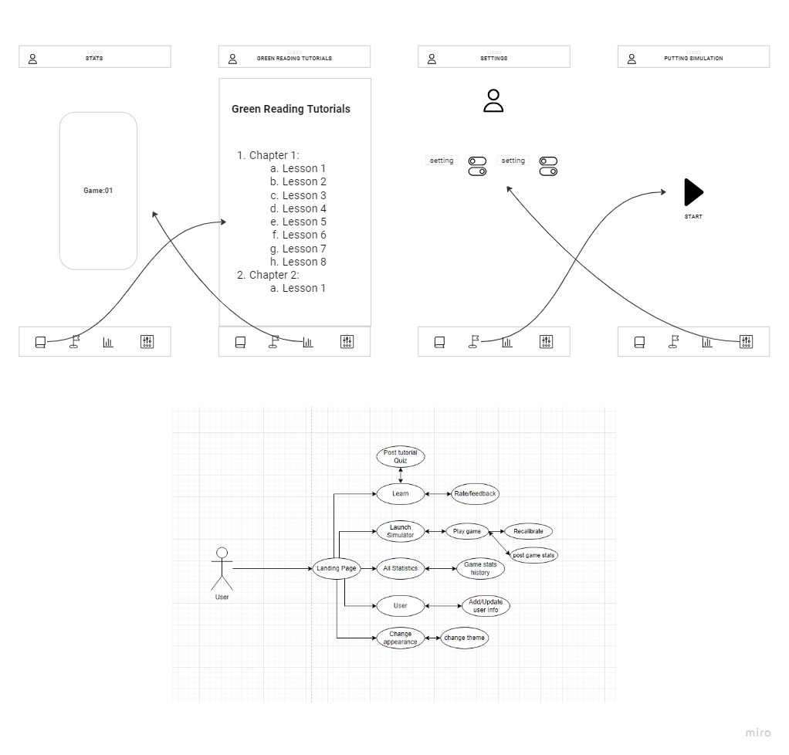

**Part 2**

# Discussion – User Involvement

In this project I engaged with 10 individuals that had different experience levels as I was trying to get different levels perspective also, I interviewed younger aged groups and older aged groups so that I can get the UI more user friendly, and I came to know different type of techniques and what problems came with those techniques.

## Current approach discussion

The engagement with the players helped me in various ways and their feedback was crucial for the initial prototype as what they wanted was what I had to develop the thing that was the most common was that they wanted real time data which I initially was not what I thought of, also all the age group wanted a simple and elegant UI, still there were some things that I couldn’t get hold of due to restrictions

Due to the absence of face-to-face interaction some of the things were limited as body language is matters and I couldn’t get hold of it also there were things like frustration during game and how user would react to my application. Also, there due to restriction I couldn’t see them in person and couldn’t judge their game and the way they see the game.

By these interactions with these individuals, I discover that clear communication plays a vital role in this app development and there were some improvements in the original design and that different aged individuals and different experienced individuals had different mindsets that the younger individuals were focused on new features while the older generation was focused on statistics provided.

## Approach with User Centred Design (UCD)

If I had full access my direct user interaction would’ve conducted in person session of usability testing also focus groups in addition to this I would’ve judged the user behaviour according to the game plan how they react to the game and It would’ve given me real time feedback on the product if they were facing with any problems and due to real time feedback I would’ve changed the interface in real time as to ease of their use and would’ve look upon the ideas and features the client would’ve added because fresh pair of eyes are always needed for final product that sees this a the eyes of user.

# Testing

## Test Plan

**Testing Purpose and Goals:**

As we dint have a working prototype so we going to act like we have a working prototype so that we can conduct these testing plans and identify if there are any problems that are occurring in the project this may include defects, security, performance or any other. Also, the main goal of these activities is to:

* Assess the usability and user experience of the high-fidelity prototype of the mobile application.
* Key goals include evaluating ease of use, navigation, engagement, and user perception.
* The testing aims to identify areas for improvement and refinement in the user interface design.

**Participants:**

We took 9 participants all ranging to different age and different experience groups and the result were repetitive as all age and experience groups have almost the same type of problems faced so these were the participants.

|  |  |
| --- | --- |
| **Participant Characteristics** | **Total Number of Participants** |
| Novice Golfers | 3 |
| Intermediate Golfers | 4 |
| Experienced Golfers | 3 |
| Total Participants | 10 |

**User Testing Task List:**

|  |  |  |  |  |  |  |  |  |  |
| --- | --- | --- | --- | --- | --- | --- | --- | --- | --- |
| **Test Condition** | **Usability Goal** | | | **How Is This Measured?** | **Benchmark** | | **Success Criteria** | | |
| Time | Steps | Achieved | | Not Achieved |
| Opening the app | Users can open the application with little to no difficulty | | | Time taken to successfully open the app | 10s | 1 | yes | |  |
| Familiar icons, Button, and navigation | Users can identify key icons, buttons, and navigation | | | Time taken to identify key icons and features | 20s | 1 | yes | |  |
| Use consistency in location of key icons, logos, and navigation | Users can predict where the navigation, logos are going to be. (don’t make me think) | | | Navigating through the pages and features, noting positioning | 20s | 2 | yes | |  |
| Recognition | Users should recognise features and objects from one page to another | | | Test users’ ability to understand what a button or feature did if it shows on the next page | N/A | N/A | yes | |  |
| Ease of use | Users should be able to navigate and use the application without complex decision making (don’t make me think) | | | Test users’ ability to use the application and navigate from one part to the next | 20s | 3 | yes | |  |
| Aesthetics with a non-cluttered appealing screen | Users should be able to identify key features and get overall clarity of the application in a glance | | | Test users’ ability to identify key features immediately | 10s | 1 | yes | |  |
| Errors and error handling | Users should be able to use the application error-free or a handling error comes up, for example if a video is not available | | | Users should test all features of the application error-free | N/A | N/A | yes | |  |
| Familiar icons, Button, and navigation | Users can identify key icons, buttons, and navigation | | | Time taken to identify key icons and features | 20s | 1 | yes | |  |
| Use consistency in location of key icons, logos, and navigation | Users can predict where the navigation, logos are going to be. (don’t make me think) | | | Navigating through the pages and features, noting positioning | 20s | 2 | yes | |  |
| Recognition | Users should recognise features and objects from one page to another | | | Test users’ ability to understand what a button or feature did if it shows on the next page | N/A | N/A | yes | |  |
| Ease of use | Users should be able to navigate and use the application without complex decision making (don’t make me think) | | | Test users’ ability to use the application and navigate from one part to the next | 20s | 3 | yes | |  |
| Aesthetics with a non-cluttered appealing screen | Users should be able to identify key features and get overall clarity of the application in a glance | | | Test users’ ability to identify key features immediately | 10s | 1 | yes | |  |
| Errors and error handling | Users should be able to use the application error-free or a handling error comes up, for example if a video is not available | | | Users should test all features of the application error-free | N/A | N/A | yes | |  |
| **User experience** | | | | | Positive experience | | | Negative experience | |
| Did you like the App | | | | | yes | | |  | |
| Were the images and graphics legible | | | | | yes | | |  | |
| Comments / Opinions | | | Well-made app | | | | | | |
| Participant Name | |  | | | | | | | |

## Test Results and Analysis

The tests were conducted, and the result was good the feedback did affect the initial prototype and some things changed when the feedback came. We didn’t have a working prototype, but the tests were conducted as if the prototype was a working one, so the results are as if we had a working one.

So, the test consisted of 10 golfers, and they were of all ages and experience but due to the restriction we couldn’t do as much but the information we got was almost enough for the final prototype to be built as more than 80% individuals did liked the prototype because of the initial build being a careful one and made by the info we got by the survey. As we didn’t have a working prototype, we didn’t get the desired result, but we did get some positive and some negative outputs.

**Overall Assessment:**

The application UI demonstrated many strengths, such as good navigation, logical icon recognition, and error handling. However, there were areas, like the clarity of green reading tutorials and engagement with real-time data, that require further improvement. this provided insights into the positive aspects and improvement in the UI.

## Findings and Recommendations

**App Navigation:**

* Findings: Users navigated effectively, with a 95% success rate and an average time of 23 seconds to complete tasks.
* Recommendations: Maintain the current navigation system and keep consistency across pages.

**Real-time Data Engagement:**

* Finding: Not all users were engaging with the real-time data feature during simulations, and not all reported improved accuracy and technique after.
* Recommendation: Improve the integration of real-time data within the simulation experience. Provide clear prompts and benefits to encourage users to utilize this feature effectively*.*

**Visual Cues for Icons:**

* Finding: Most users were able to identify icons and buttons effectively, but a small percentage took longer to do so.
* Recommendation: Provide better visual cues upon hovering over icons to aid users who may need more guidance.

**User Information:**

* Finding: The user didn’t find anything linking to their own information
* Recommendation: Add another screen which consists of the user’s information and their playing style

**Image Processing Integration:**

Implement advanced image processing and visualization techniques to provide users with a more immersive and informative putting experience. This can include enhanced visualization of green contours, ball movement, and trajectory, aiding users in better understanding green reading nuances.

# Discussion – Accessibility

When I designed the application, I looked at how users would react to my product as the age groups that will use the app is the older generation as they are most likely to use the application in relation to accessibility demands. With the older generation I had to consider layout, navigation, readability, as these are the key attributes that affect the older generation.

My product can almost be used by 80-90% of the target user so I just need to make some changes that the other % of people can use my application.

For example I have to add font size for people that can’t see small writing and also for people with colour blindness I have to make some changes in order to meet those criteria also the colour I used are one of the simplest ones that are seen visibly even to a person with colour-blindness still I need to change some of the things in my Ui in order to make it assessable to everyone

# Prototype

## Stage Two – High-Fidelity Prototype

So, the high-fidelity prototype consist of almost 6 screens and every screen serves their purpose as the screens have the initial suggested colour scheme green and white with a hint of grey also the statistics were added to give an average of score of, the game played and also some of the surveys were taken on the high-fidelity prototype looks similar to the final product that we want to achieve.

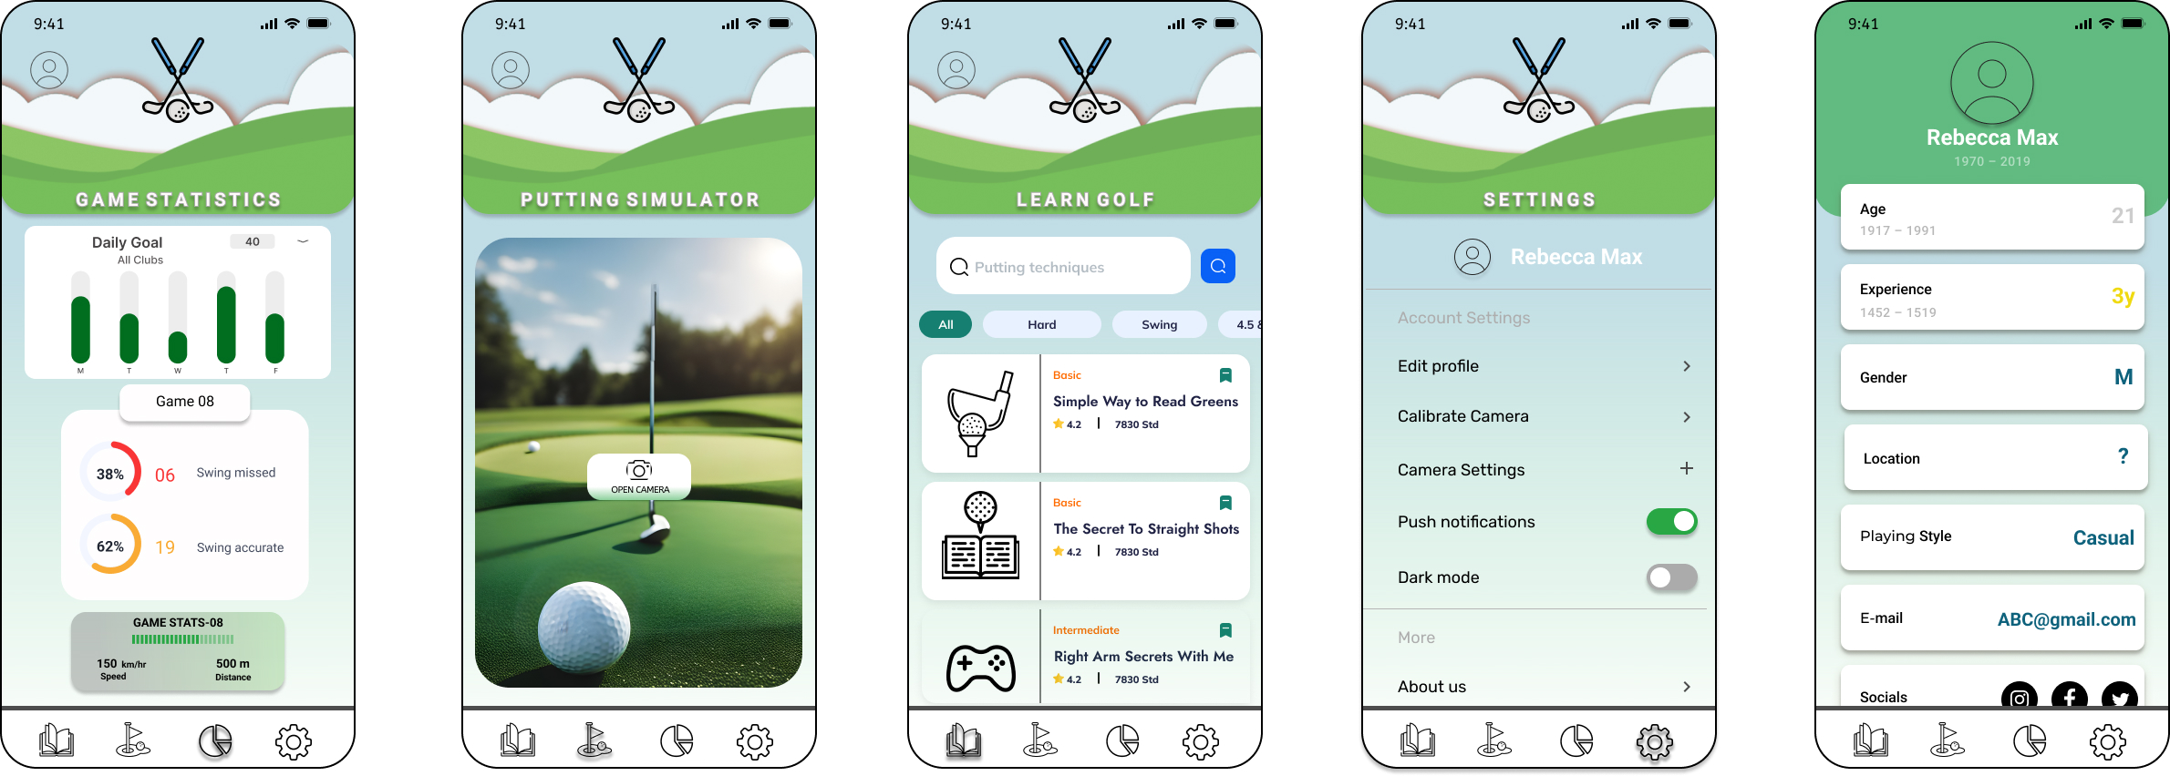

Figure 6 high fidelity prototype

**Landing Page:**

Figure 7 Landing page

The landing page consist of an user icon on the top and a logo on the top centre and we changed the font size to a bigger one in order to aid visibility to the elderly also because the test suggested that we use a daily goal to show the progress f the person who plays regularly so we added the daily goal showing whether the user achieves the daily goal or not and then we changed the game statistics to look more simple and less complex so that it be easily be read also we added the game ang stats after the game has been played the user can see whether his swings were a good hit or not this will help him in achieving their goal and be good at golf.

**Putting Simulator:**

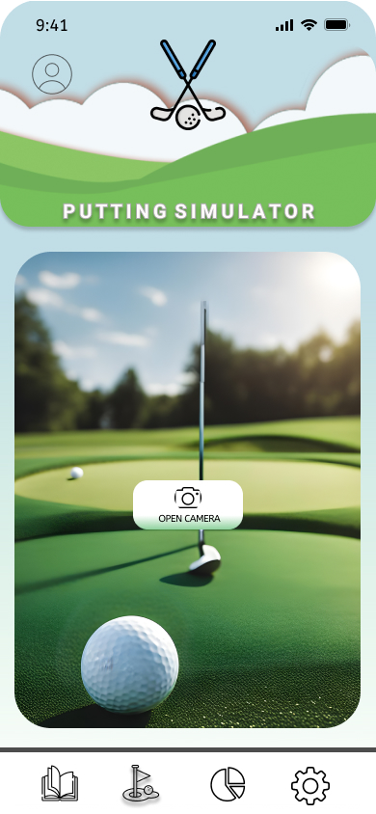

Figure 8 Putting Simulator

The putting simulator looks like simple simulator but once you click the camera icon it opens the camera and after that image processing takes place in locating the ball and when the club hits the ball it takes you to the stats page where it shows you all the stats of the shot or shots.

**Learn Page:**

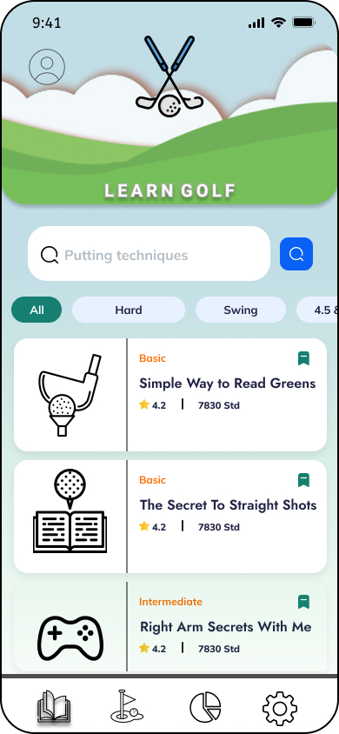

Figure 9 Learn Golf Page.

The learn page shows all the course and what their stage is either it is expert or is it basic so this is the one of the improvement that we got from the tests analysis also we also added the search bar that can search whatever course you want to watch also we added rating to the courses this is also one the things that were added after the test analysis.

**User Profile:**

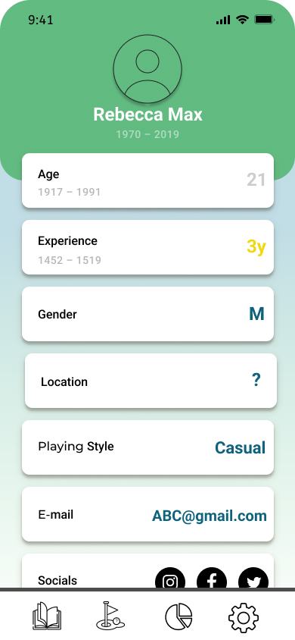

Figure 10 User Page

We did not include the user page before but after the test analysis individuals asked for the user page which had all the user information and the details about what type of player is the user and what his socials are and how experienced the payer is.

**Settings Page:**

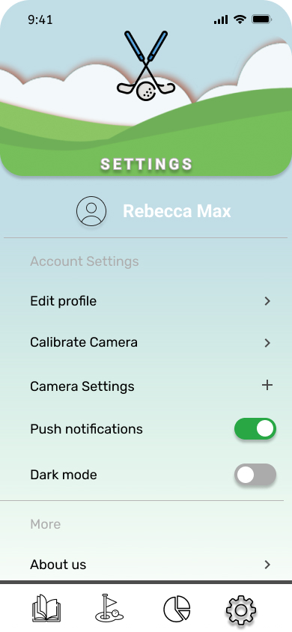

Figure 11 Settings Page

The setting page is basic page consisting of the necessary options that you would get in the application legal policies, about us and much more we also added the dark mode for people who don’t like the white, green theme it would take them to a dark black and grey theme also It contains the user information. Also, we added the resize font size in edit profile menu so that people with disability can make sure it suits them.

# Discussion – Contexts of Use

A green screen golf simulator which is created for pro players to practice and by that it feels like you are on the field and is used to improve skills and precise putting techniques making this the best machine for players that train every day. However, to make it work in a different context, several modifications are necessary:

* **Simplified Interface:** The interface should be user-friendly and intuitive, catering to a broader audience. making it accessible to novice golfers and families
* **Entertainment Features:** Small gamification elements like mini-golf courses, and rewards to transform it into an enjoyable home entertainment system. Users can have fun with the it and improve their putting skills at home.
* **Accessibility:** Make sure the system works with various mobile devices and platforms, such as smartphones, tablets, or even gaming consoles like Xbox or PlayStation, to access a wider audience.
* **Remote Learning:** Integrate remote learning capabilities, allowing users to connect with golf instructors virtually. This feature could be monetized through subscription models, enabling users to receive personalized training sessions.
* **Augmented Reality (AR) Integration:** Add AR technology to create immersive home putting experiences. Users can turn their living rooms into virtual golf courses.
* **Compatibility with Home Entertainment Systems:** Make the simulator compatible with popular home entertainment systems like TVs, enabling users to play on a big screen.
* **Multiplayer Functionality:** Include multiplayer modes, allowing friends and family to compete against each other, further enhancing the recreational aspect.

# Discussion – Emerging Technology

One emerging technology that could transform the golf putting simulator is Artificial Intelligence (AI). By adding AI, the simulator could analyse a golfer's putting technique in real-time, providing personalized feedback and coaching.as both AI and AR can make the biggest improvement in the golfer’s game that could even help the best players all over. It could also adapt difficulty levels, create custom training plans, and simulate various environmental conditions, enhancing the user experiences and skills development.

If there were no constraints, I would like to expand the product into a golf training ecosystem. This would include additional modules for driving, chipping, and sand play, all integrated into a single platform. I would also invest in advanced AI and AR technologies to create the most immersive and effective golf training experience possible. Additionally, I'd make partnerships with major golf organizations and professionals to promote the product globally.so that my product can reach out the world an make more advancement to itself.

# Conclusion

This design brief underscores the paramount importance of user-centric design in the realm of technology. It illuminates that while technology advances swiftly, fundamental human interactions with it remain relatively stable, rooted in sensory perception and cognitive reasoning.

In the field of Human-Computer Interaction (HCI), this brief emphasizes the need to align design principles with enduring human nature. It highlights the significance of empathy, research, and adaptability in creating technology that enhances lives.

# References

BrowserStack. (n.d.). Manual Testing Tutorial. <https://www.browserstack.com/guide/manual-testing-tutorial>

Global App Testing. (n.d.). Software Testing: The Ultimate Guide. <https://www.globalapptesting.com/blog/software-testing>

UXPin. (n.d.). High-Fidelity Prototyping vs. Low-Fidelity Prototyping: What's the Difference?   
<https://www.uxpin.com/studio/blog/high-fidelity-prototyping-low-fidelity-difference/>

World Economic Forum. (2023). Top 10 Emerging Technologies of 2023. <https://www.weforum.org/reports/top-10-emerging-technologies-of-2023/>

# Appendix Part 2

## Appendix 1.2 – Consent form example

Application Research and Evaluation Consent Form

Researcher: Your Name

Department: [Your Department]

Purpose of the Study:

You are invited to participate in a research study focused on testing a new mobile application for golf putting simulation. Before you decide to participate, it's essential to understand the research and the nature of your involvement. Please carefully read through this informed consent and feel free to seek clarification on any aspects.

Study Procedures:

Should you choose to participate, we will collect some personal information, including your age, background, proficiency with technology, and your experience with interactive applications. Approximately 5 to 10 individuals will be invited to take part in this research, and your participation will require approximately 15 minutes of your time. We assure you that the information collected will not be shared with any third parties. Statistical and non-identifiable personal information will be used exclusively to enhance our golf putting simulator application.

Duration:

This study will take no more than 15 minutes per participant, which includes a brief set of questions and the testing and evaluation of the golf putting simulator application. The study will conclude with a few quick questions.

Voluntary Participation:

Please understand that your participation is entirely voluntary. You have the sole discretion to decide whether to participate or not.

Non-Disclosure:

You are obligated not to disclose any information about the golf putting simulator application to third parties without written consent. Additionally, you are prohibited from replicating or duplicating any features, content, or images from the application as it falls under our intellectual property and copyright protection.

Consent:

By initialling below, you confirm that you voluntarily give your consent to participate in this study. You have read and understood the information provided in this consent form, or it has been read to you, and any questions you had have been satisfactorily addressed to your contentment.

validate that you have read the entire form. __________

Name: _________________________ Signature: _________________________

Date: _________________________

## User Testing Photos

Conceptual using Story Board

Identifying icons:

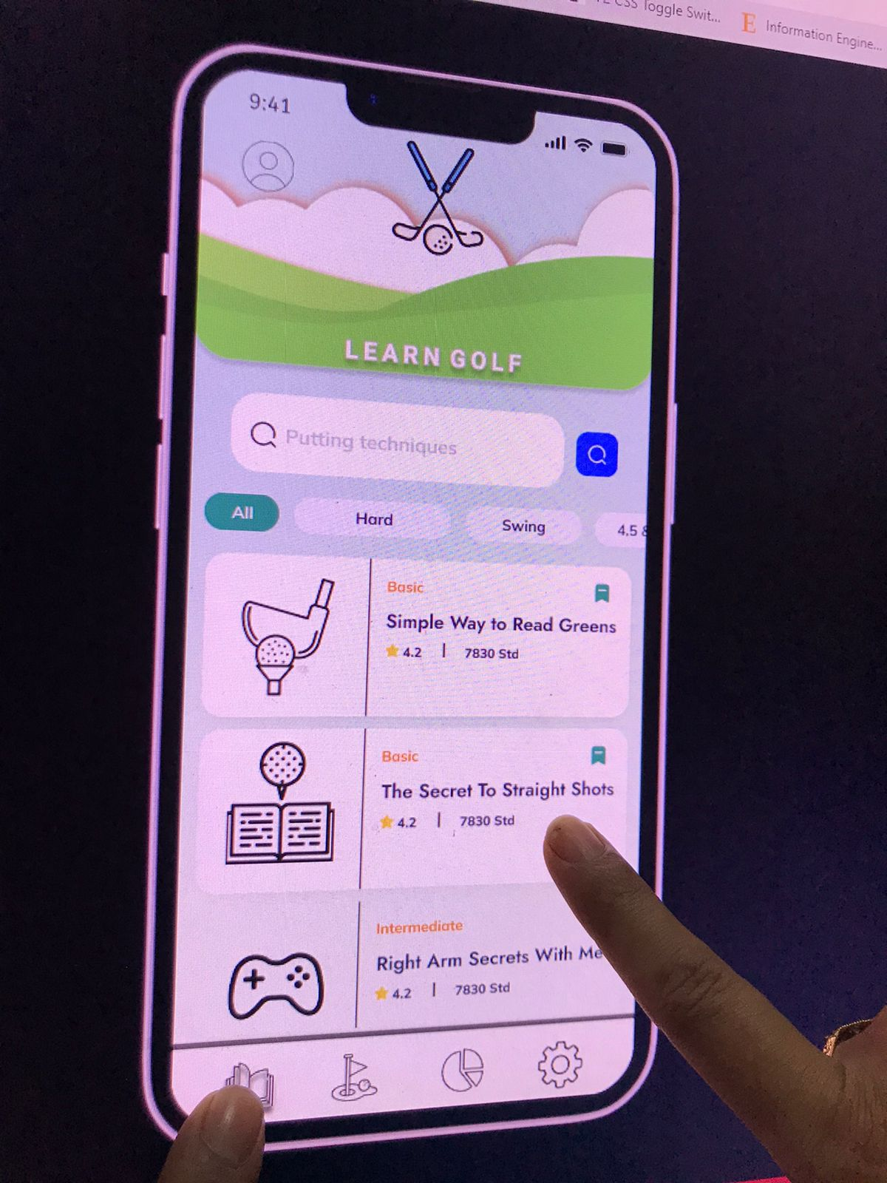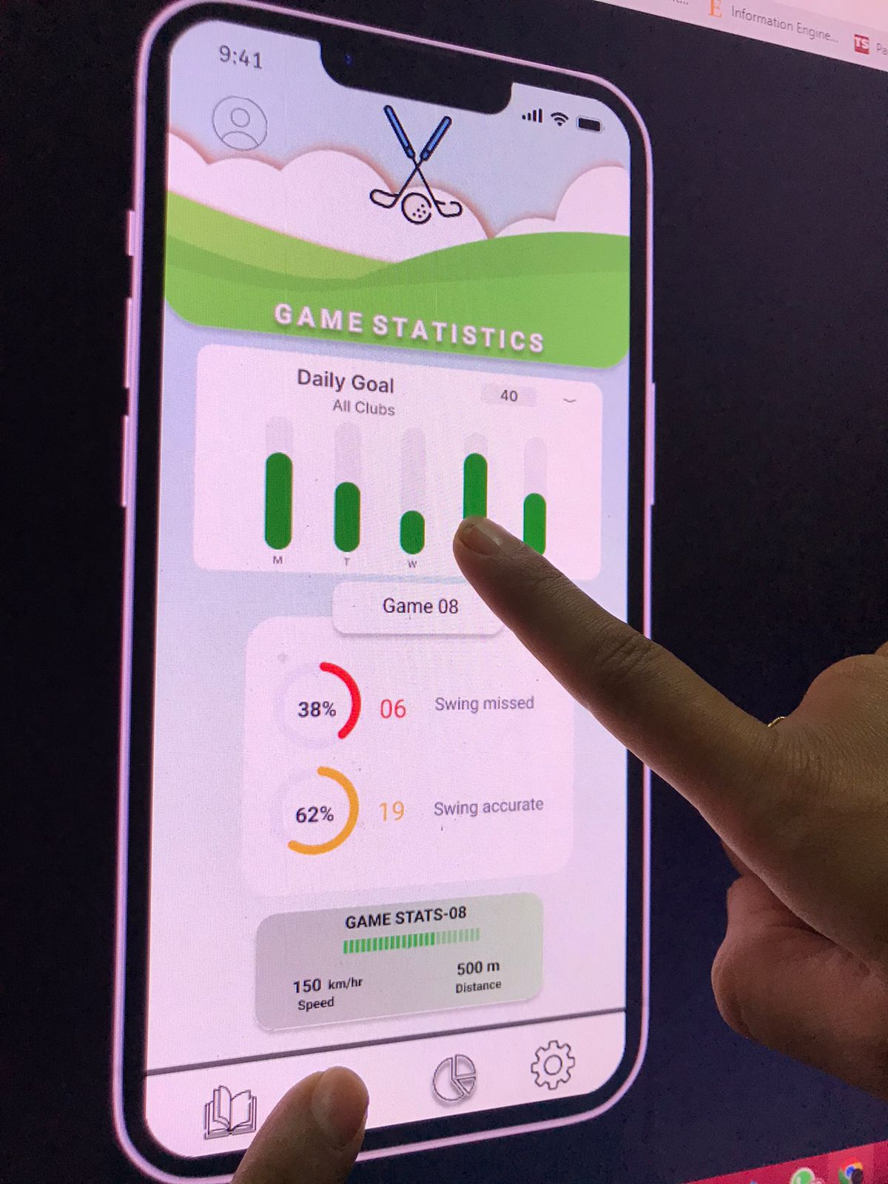

Play game:

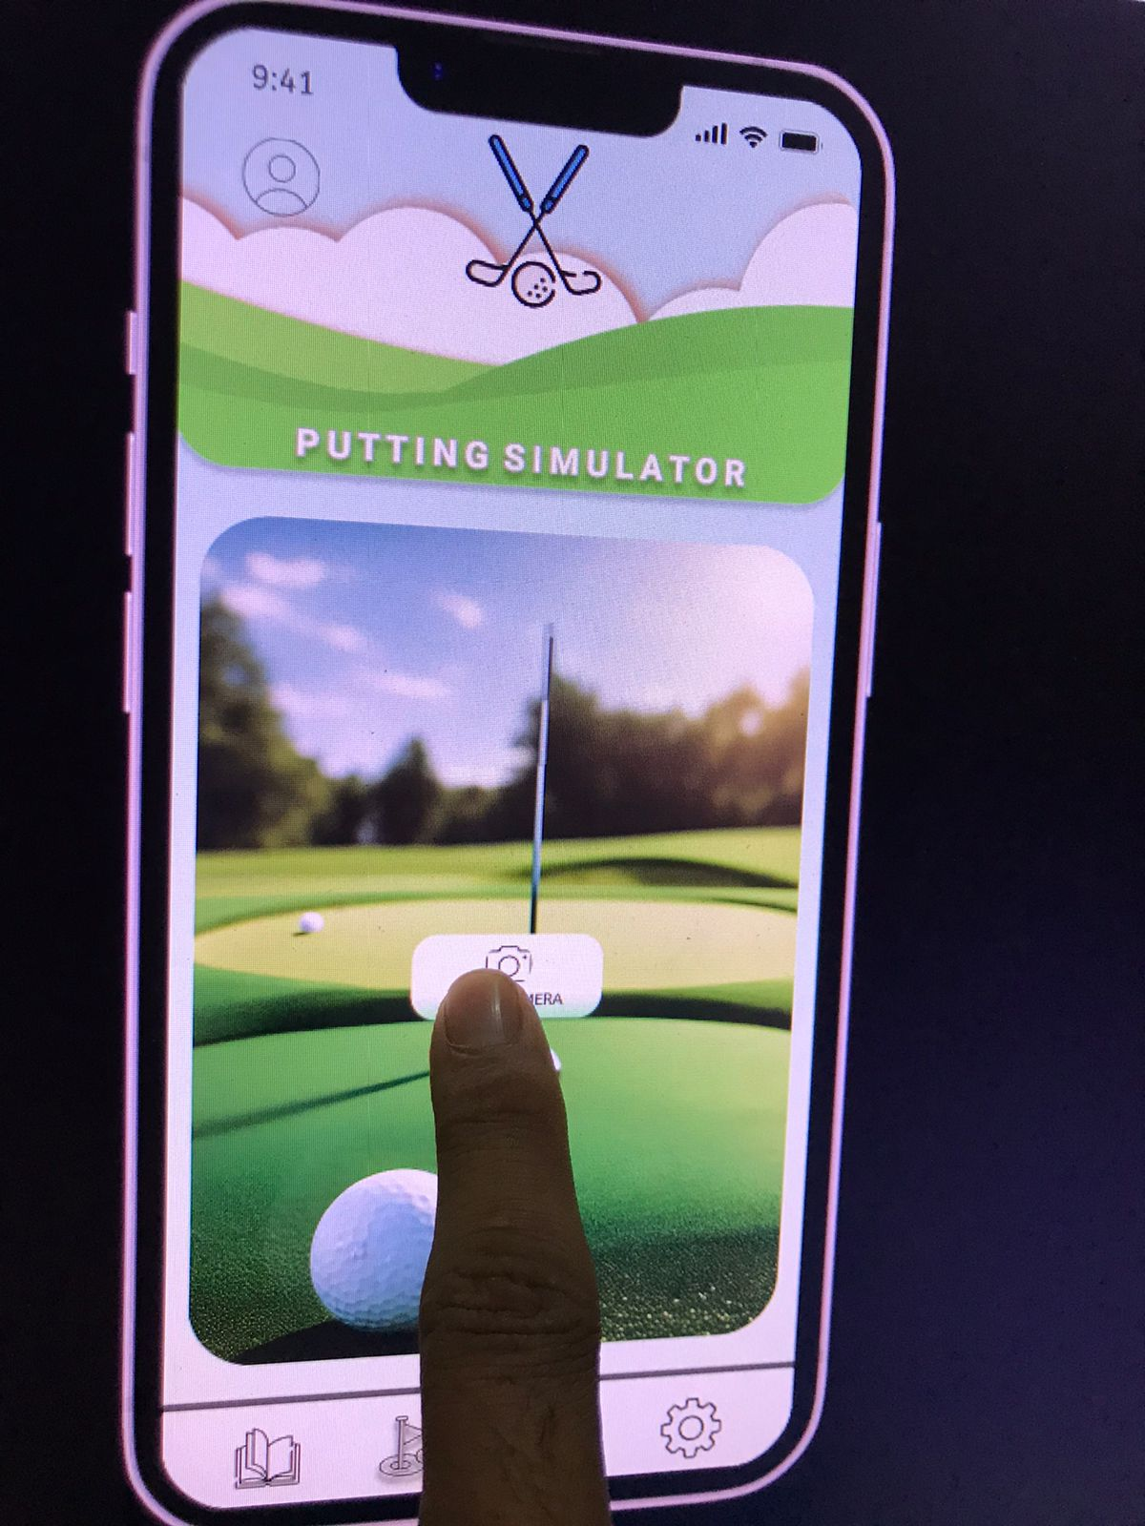

User profile:

